

PROJECT REPORT ON

GLOBAL SUPERSTORE DATA

Course: BDA100NAA
Instructor: Omid Aghababaei Tafreshi
Prepared by: Rishi Raj Das, Luka Lazarev, Duy Bao Khang Nguyen
Student ID: 165212234, 143871242, 185000239

GLOBAL SUPERSTORE DATA 1
Descriptive Statistics 2
1.1 Dataset 3
1.1.1 Introduction 3
1.1.2 Dataset Characteristics 3
1.2 Categorical Variables 3
1.2.1 Frequency Tables 3
1.2.2 Pivot Tables 4
1.3 Numerical Variables 6
1.3.1 Sales Data Summary 6
1.3.2 Histograms 7
1.3.3 Box Plot 8
Linear Regression 9
2.1 Summary: Sales vs Profit 10
Time Series Analysis 10
3.1 Data Refinement Process 11
3.2 Forecasting Methods Used 11
3.3 Time Series Patterns 11
Supplementary Information 12

Descriptive Statistics

1.1 Dataset

1.1.1 Introduction
This project utilizes a retail dataset from a global superstore, covering four years of transaction data. The dataset includes detailed records of customer purchases, shipping details, and product information. Through this data, the project aims to uncover key business insights related to customer behavior, product performance, and regional sales trends.
To achieve this, three core data analysis techniques were applied:
- Descriptive Statistics to summarize and visualize data distributions.
- Linear Regression to model the relationship between sales and profit.
- Time Series Analysis to forecast future sales trends.
The goal is to support decision-making in marketing, inventory planning, and sales strategies, while also working to improve profit margins through data-driven insights.

1.1.2 Dataset Characteristics
- Number of instances (rows): 9,800
- Number of variables (columns): 18
- Numerical variables: Row ID, Postal Code, Sales, Profit.
- Categorical variables: Order ID, Order Date, Ship Date, Ship Mode, Customer ID, Customer Name, Segment, Country, City, State, Region, Product ID, Category, Sub-Category, Product Name.

1.2 Categorical Variables

1.2.1 Frequency Tables
We analyzed categorical variables from the retail dataset by constructing frequency tables for key fields. These tables include frequency, relative frequency, cumulative frequency, and cumulative relative frequency.
Below are the results and interpretations for two categorical variables: Category and Region.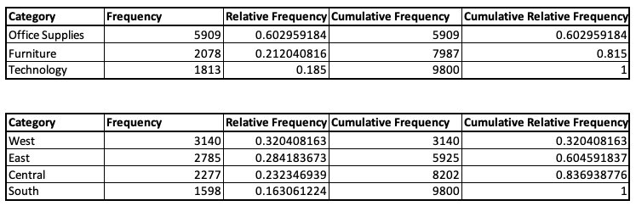
Product Category Sales
- Office Supplies account for most sales, contributing approximately 60.3% of total transactions.
- Furniture represents the second largest category, with 21.2% of total sales.
- Technology holds the smallest share, contributing 18.5% of sales. Combined, Office Supplies and Furniture account for over 80% of all product category sales, highlighting their significance in the company’s revenue stream.
Regional Sales Distribution
- The West region leads in sales performance, making up 32% of all recorded sales.
- The East region follows closely, contributing 28.4% of sales.
- The Central region accounts for 23.2%, indicating moderate performance.
- The South region contributes the least, with 16.3% of total sales.
- Together, the West and East regions contribute more than 60%, making them crucial markets for focused business strategy and resource allocation.

1.2.2 Pivot Tables
This Pivot Table contains the top cities by their sales volume:
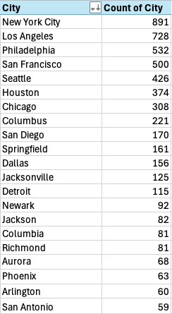 | Key Highlights:  - Over the 4-year period, New York City had the highest number of orders (891), followed by:  - Los Angeles (728)  - Philadelphia (532)  - San Francisco (500)  - Seattle (426)  - These top 5 cities alone account for a significant share of total orders.  Urban hubs dominate the sales volume, reflecting high demand in major metropolitan areas.  - The top 20 cities collectively represent a strong concentration of customer activity  There are hundreds of other cities with lower order volumes, but the focus here is on the highest-performing locations for clearer insights.  Implications:  - Marketing efforts and stock planning can be prioritized in top-performing cities.  - High-order cities may benefit from regional promotions, faster delivery options, and localized inventory management.

The next Pivot Table is a profit breakdown by region & shipping mode:
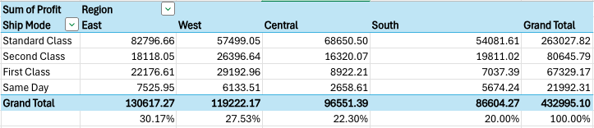

Key Insights:
East Region leads in profitability, contributing over 30% of total profit (≈$130K), followed by:
West: 27.5%
Central: 22.3%
South: 20%
The most profitable shipping mode across all regions is Standard Class — generating over $263K, which is more than 60% of total profit.
East & West benefit significantly from First Class and Second Class, suggesting premium shipping is more profitable in these areas.

The last Pivot Table shows us the profitability by product sub-category:
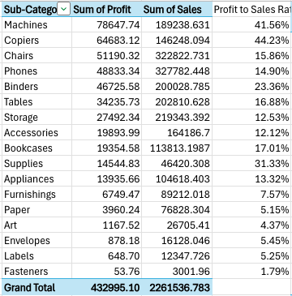 | Top Performers – High Profit & Efficiency:  - Copiers (44.23% profit margin) and Machines (41.56% profit margin) lead in both profit and profit-to-sales ratio.  - Though not top in sales, these items yield exceptional returns and are key drivers of overall profitability.  High Sales, Moderate Profitability:  - Phones, Chairs, and Binders generate significant sales volume but show lower profit margins:  - Phones: 14.9%  - Chairs: 15.86%  - Binders: 23.36%  - These are core products, but margins can be optimized.
Balanced but Underperforming:
Storage, Accessories, and Furnishings have moderate sales but below-average profit ratios (7–13%). These may benefit from pricing reviews or promotional repositioning.

1.3 Numerical Variables

1.3.1 Sales Data Summary
Min | 2.025
Max | 28106.716
Average | 1838.647791
Q1 | 378.519
Q2 | 1058.397
Q3 | 2382.217
Q4 | 28106.716
The quartile values provide a summary of the distribution of sales across all transactions in the dataset:
Q1 (First Quartile = 378.52):
This means that 25% of all sales transactions are less than or equal to $378.52. These represent low-value sales and could correspond to smaller or discounted items.
Q2 (Median = 1058.40):
The median sales value is $1,058.40, indicating that half of all sales fall below this amount, while the other half exceed it. This serves as a central reference point for typical transaction sizes.
Q3 (Third Quartile = 2382.22):
75% of sales transactions are less than or equal to $2,382.22. Only the top 25% of sales exceed this value, showing the threshold for high-value purchases.
Overall, the interquartile range (Q3 - Q1) of approximately $2,003.70 reflects the spread of the middle 50% of sales. This highlights the presence of a moderate variation in transaction values, with a small percentage of exceptionally large sales (seen in the max value of $28,106.72) pushing the average higher than the median.

1.3.2 Histograms
1. First histogram is about the monthly sales distribution:
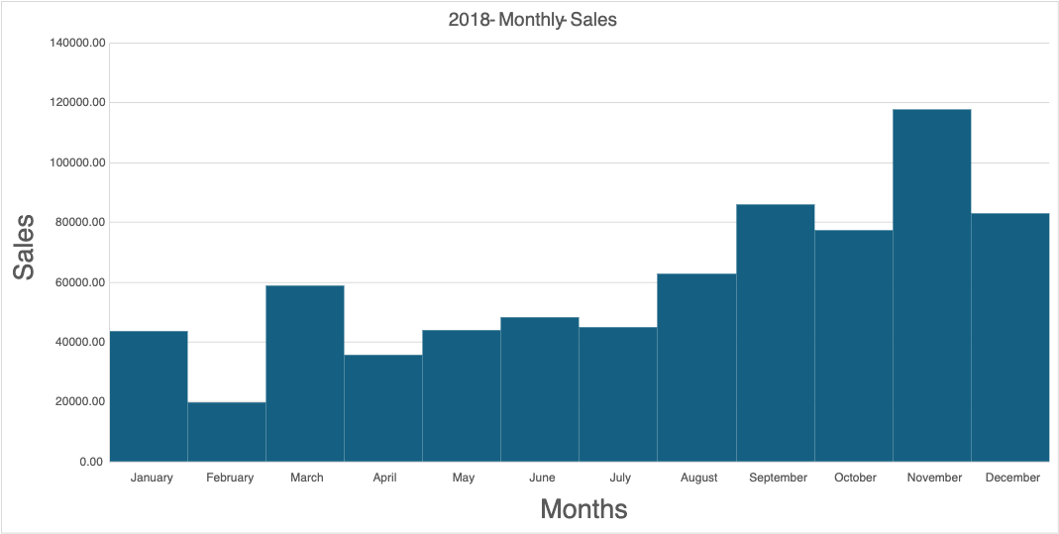
- Distribution: Left-skewed – most sales in lower-to-mid range, peak towards year-end.

- Peak Months: Major spike in November ($117K) and December ($83K) due to holiday season.

- Lowest Sales: February ($19K) – shortest month, low activity.

- Trend: Gradual rise from August onward, highlighting strong Q4 performance.

- Insight: Focus marketing & inventory efforts in late-year months.

2. The next histogram is about the regional sales distribution:
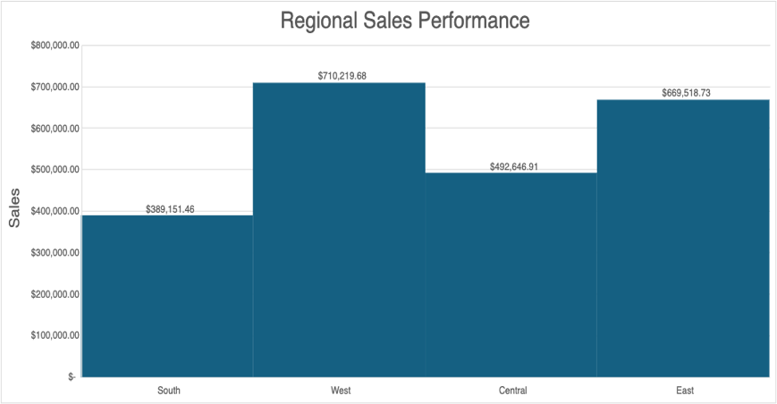 | - West region leads with the highest sales at $7.1M & East follows closely with $6.7M.  - Clear performance gap between top (West, East) and lower (Central, South) regions.  - Suggests stronger sales strategies or market potential in West and East & highlights opportunities for growth in South and Central regions.

1.3.3 Box Plot
1. First is a box plot related to the yearly sales:
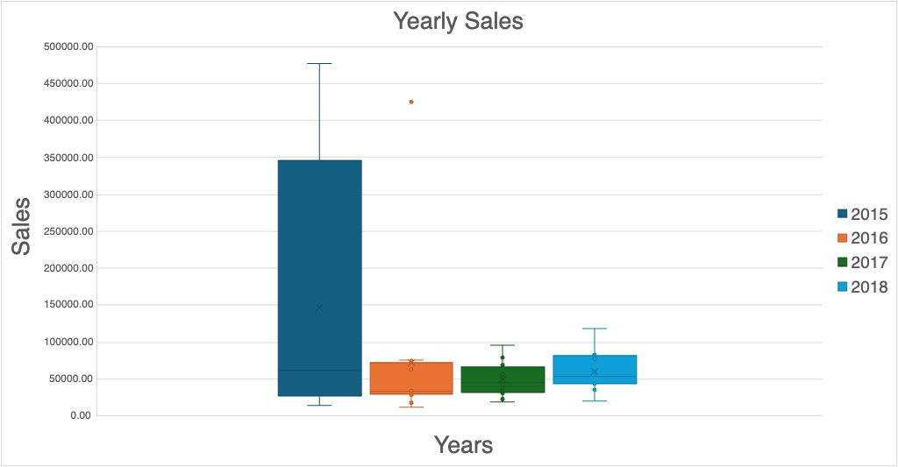
Variability:
2015 & 2016 show exceedingly high variability due to extreme sales spikes in Feb–July (outliers).
2017 & 2018 have more consistent sales, showing lower variability.

Distribution:
2017 & 2018 distributions are more balanced with tighter IQRs.
2015 & 2016 are skewed due to abnormally high sales months.

Outliers:
Large outliers in 2015 (Feb–July) and 2016 (June) inflate overall sales.
2018 has the least outliers, indicating more stable monthly performance.

2. The next one is a box plot related to the regional:
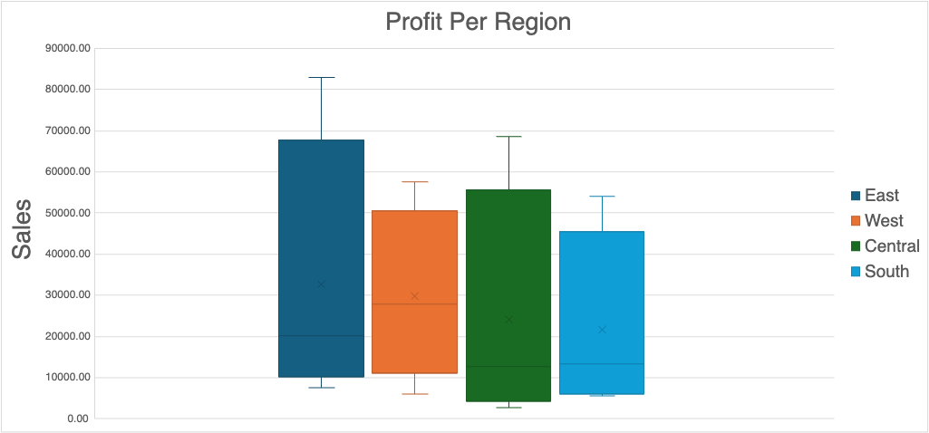 | - High variability in profits, especially in the East and Central regions.  - Standard Class profits in East and Central is outliers.  - South shows the least variability.  - Distribution is right-skewed due to high-profit values.

Linear Regression

2.1 Summary: Sales vs Profit
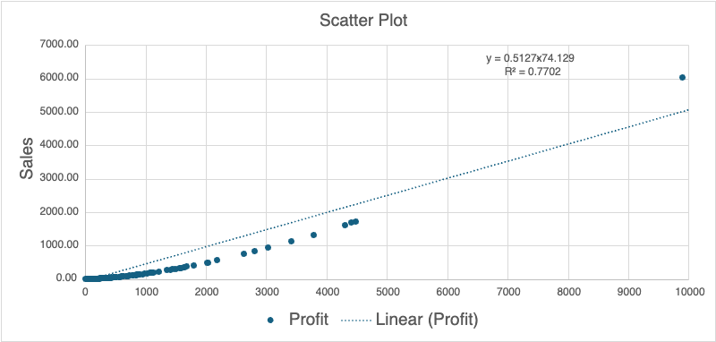

The scatter plot of Sales vs Profit reveals a strong positive linear relationship between the two variables. This is supported by the following key findings from the regression model:
Correlation Coefficient (r = 0.8776):
- This value is remarkably close to 1, indicating a strong and positive linear correlation. As sales increase, profits also tend to increase proportionally.

Regression Equation:
Profit = 0.5127 × Sales – 74.13

- The slope (b1 = 0.5127) means that, on average, every 1 dollar increase in sales is associated with a 0.5127 cent increase in profit.

- The intercept (b0 = -74.13) suggests that when sales are zero, the predicted profit would be approximately –74.13, which can be interpreted as a baseline or fixed cost in this context.

R^2 (R^2 = 0.7702):
- This means that 77.02% of the variability in profit is explained by the variation in sales, indicating that the model provides a good fit. The remaining 22.98% of variability is due to other factors not captured by the model.

Time Series Analysis

3.1 Data Refinement Process
Started with a raw dataset containing every individual transaction made over 4 years, each with its exact date.
Cleaned and filtered the data to focus only on relevant fields, Order Date and Sales.
Grouped transactions by year and month to calculate the total monthly sales for each year (2015–2018).

3.2 Forecasting Methods Used
Used the refined monthly sales data to perform Time Series Forecasting using 4 key methods:
Naive Method – Uses the most recent value as the forecast.
Average Method – Forecasts based on the average of all past sales.
Moving Average – Smooths fluctuations using the average of recent periods.
Exponential Smoothing – Applies greater weight to recent data for more responsive forecasting.

3.3 Time Series Patterns
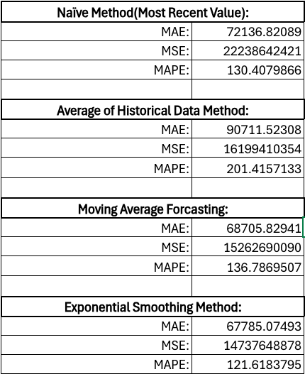 | Among all four methods, Exponential Smoothing performs the best based on lowest error values.  Why Exponential Smoothing is Better:  - Lowest MAE (Mean Absolute Error): Gives more accurate predictions.  - Lowest MSE (Mean Squared Error): Reduces large forecasting errors.  - Lowest MAPE (Mean Absolute Percentage Error): More consistent and reliable percentage-based accuracy.  It adapts quickly to recent changes in data, making it more responsive and ideal for dynamic sales trends.  Using Exponential Smoothing, the predicted sales for Jan 2019 is:  $ 75,053.96

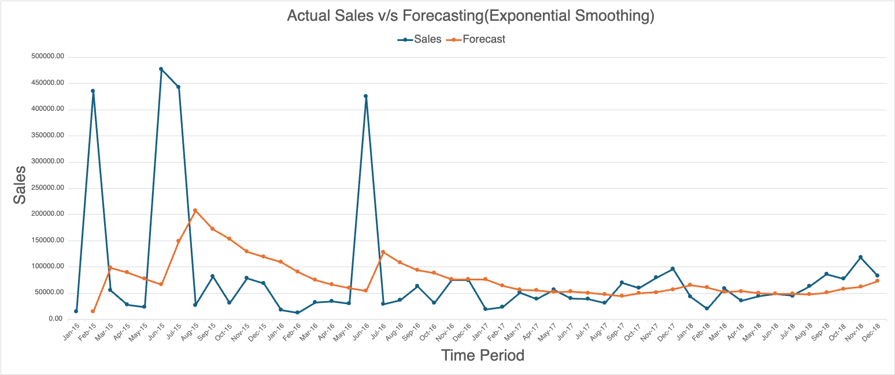

Supplementary Information
Dataset Information:
Superstore Sales Dataset
link: https://www.kaggle.com/datasets/rohitsahoo/sales-forecasting/data
Project Documents:
Presentation: BDA100_Project_Final.pptx
Report: BDA100_Project_Report.docx
Excel Workbook: BDA100_Project_Final.xlsx
Course Details:  Course: Introduction to Data Science  Course Code: BDA100NAA  Instructor: Omid Aghababaei Tafreshi | Group 2:  Rishi Raj Das, 165212234  Luka Lazarev, 143871242  Duy Bao Khang Nguyen, 185000239
Note: access to the documents has been given to @seneca.ca emails.

